# How do individuals react to shocking news? An exploration of Youtube Comments using NLP and Sentiment Analysis

SAM COHEN

DANIEL CÁRDENAS SÁNCHEZ

GABRIEL ANDRÉS SOTO

Georgetown University, United States

Previous literature has shown that negative shocking news are related to impacts on people’s mental health and societal implications. This report compares different kinds of news (horrific, scandal and pop) to determine the differences in people’s reactions via video comments on Youtube. In general, it was found that horrific news and scandal news have more negative reactions than pop news. Also, higher probability weight on scores positive, negative, and neutral scores may lead to higher likes, interactions and comments. Over time, the amount of positive and negative comments decreased, indicating that there were more “unclassified comments” (i.e. comments that could not be classified as positive/negative/neutral) as time went on.

*Keywords: sentiment analysis, Youtube, shocking news*

## Introduction

With the advent of the internet and the increase in Smartphone usage across the world, the speed at which individuals can obtain information and news has never been faster. This interconnectedness comes with problems, however. The spread of misinformation, political extremism, decreased mental health among users, and polarization are just a few consequential examples. These phenomena provide researchers with a looking glass into public sentiment regarding certain issues, which can often be found in some of the darkest places on the web: Youtube’s comments sections.

Our research will attempt to answer the following research question(s): How do individuals react to different types of shocking news on Youtube? Specifically, how do they react to “horrific” news, “scandalous” news, and “pop” news? Will these comments be “positive”, “negative”, or “neutral?” Understanding these types of reactions can help policymakers create better strategies to mitigate polarization, mental health issues for users, and extremism in social media.

We have 2 hypotheses for our research:

*H1: Individuals will react mostly positively to pop culture news, negatively towards horrific news, and have comparably more neutral reactions towards scandalous news. People will be more likely to react the more the news affects them (either positively, negatively, etc.).*

*H2: The share of neutral comments will increase over time.*

### Literature Review

Shocking news events have significant impacts on both the individual and societal level. Poutvaara and Ropponen found that news of school shootings can have negative effects on mental health and thereby outcomes such as test scores or polarization (Poutvaara and Ropponen 2018; Koutra et. al. 2015). Koutra et. al. also found that individuals consume news from sources that match their ideological tendencies (Ibid). Chen et. al. observed that consumption of ideologically extreme content on Youtube is often concentrated within smaller groups (Chen et. al. 2013). Individuals also often seem to prefer to consume negative news over positive news, which can have more of an effect on individuals if they have an emotional connection to the subject of said news (De Hoog and Verboon 2019).

Sentiment analysis is the use of methods such as natural language processing (NLP) and various text-as-data processing methods to observe trends, patterns, and beliefs in online reviews or comments (Hussein 2018). The use of sentiment analysis in relation to news is well-documented, and it occupies a substantial niche in current literature. When classifying comments as positive, negative, or neutral, for instance, [Mukwazvure](https://ieeexplore.ieee.org/author/37085701288) and Supreethi found that Support Vector Machine was more successful at identifying neutral articles than K-Nearest Neighbor ([Mukwazvure](https://ieeexplore.ieee.org/author/37085701288) and Supreethi 2015). Sentiment analysis on Youtube comments found that comments made in response to others were mostly negative in sentiment, with religion being the topic that generated the most replies (Thelwall et. al. 2011).

### Overall report summary and findings

Comments with positive sentiments, along with comments with negative sentiments, received more likes on average than neutral comments and comments that were not classified. This was the case for all news categories. These findings were statistically significant. This helped confirm H1. However, neutral comments did not become more prevalent over time, as hypothesized in H2.

## Data and Methodology

For the purposes of our research, and aligned with the literature, “shocking news” will refer to news that may evoke a strong or quick reaction for individuals. Within this scope, “horrific” news will refer to shocking news with a negative outcome. “Scandalous” news will refer to shocking news dealing with scandals, the outcome of which may be positive or negative depending on the individual. “Pop” news will refer to shocking pop culture news, which, while not necessarily positive or negative in outcome, will be much “lighter” in content than either scandalous or horrific news.

We used Youtube’s API[1] to extract video and comment data dealing with three separate events that fall under each shocking news category above: The Uvalde School Shooting (“horrific news”), the indictment of Senator Bob Menendez (“scandalous news”), and Taylor Swift dating Travis Kelce (“Pop news”). We developed queries to use with the API, and extracted video and comment data for each category using specific key words and dates (e.g. “query: Menendez, indictment, bribe; date: '2023-09-22'; n-days: 14”). We only retrieved data from the first 14 days of each event’s occurrence, since we believed this was when the bulk of content and comments regarding each subject would lay. Extracted video data consisted of the video name, channel, URL, description, view count, comment count, like count, and date posted. Comment data includes the comment text, the video in question, the channel, the date of the video where the comment was posted, and the number of likes the comment received. We also generated a new variable called “Comment Score,” which sums the number of likes each comment received, and adds one to this number. We generated this variable to help develop a better picture of how to perceive the weight of each comment and reaction of users: since we do not have data on comment replies, the number of likes each comment receives can help determine how “popular” it was, and in turn, the sentiments of other users who may not have commented. We added one to the number of likes a comment received to account for the sentiment of the original posters, who may or may not have liked their own comment .

In order to generate sentiment analysis for our comment data for each of the three news categories, we used models from Hugging Face, called “Distilbert.” This package generated probability scores for each comment’s sentiment. For example, a comment may receive a positive probability score of 0.7, a negative probability score of 0.2, and a neutral probability score of 0.1 (probability scores add up to one).

Given these scores, we assigned dummy variables to each sentiment if their respective score was greater than 0.7. For example, if a positive sentiment probability score for a particular comment was 0.9, then the category “positive_dummy” was designated as “1”, and so on for the negative dummy variable and neutral dummy variable.

With this data, we were able to set up the blueprint for our analysis. For example, we were able to use the Pandas package to wrangle our data to determine the number of comments and videos each category experienced on a particular day by merging the data and comments data frames on the day published variable, the average positive, negative, and neutral probability sentiment scores for those days, the trend in comments and probability scores over time, and how much these scored varied within a particular day or category.

## 

## Analysis

Overall, data on 402,534 comments were collected. Specifically, 49,952 comments relating to Taylor Swift and Travis Kelce dating (i.e. “pop” news) were collected, along with 66,197 dealing with the indictment of Robert Menendez (“scandalous” news) and 286,385 on the Uvalde school shooting (“horrific” news). These comments were posted under videos released during the first 14 days after each respective event occurred. It is important to note that the date of each comment does not refer to the date it was made, but rather the release date of the video it was posted under. Regarding videos, we collected data on 427 videos dealing with “pop” news, 455 on “scandalous” news, and 339 on “horrific” news. We were able to wrangle our data using pandas to group the number of comments by day (including corresponding sentiments), as well as the number of videos posted per day. We then merged these two data frames to calculate and generate graphs for the number of comments per video by day, comments score and number of likes per day, average sentiment scores by day, and number of positive, negative, and neutral comments by day.

After using the “Distilbert” model obtained from Hugging Face, the sentiment analysis for comments on each respective type of shocking news was analyzed. The average “pop” positive sentiment probability score for comments was 0.443, the average neutral sentiment probability score was 0.212, and the average negative sentiment probability score was 0.345. For “scandalous” news, the average positive probability score was 0.290413, the average neutral probability score was 0.183, and the average negative probability score was 0.526. For Horrific news, these scores were 0.294, 0.179, and 0.526787 respectively.

As mentioned previously, comments were also classified as being “positive,” “negative,” or “neutral” (all dummy variables) if their probability score for each respective category was greater than 0.7. For “pop” comments, 10.43 percent of all comments were classified as positive (the plurality), with 5.11 percent being classified as negative and 0.088 percent being neutral. The remaining comments did not meet the thresholds for classification. For “scandalous” news, the plurality of comments (25.21 percent) were negative, with 5.22 percent being positive and 0.085 being neutral. 28.18 percent of “horrific” news comments were negative (the highest plurality of all categories), 7.91 percent were positive, and 0.075 percent were neutral. These dummy variables were used to generate difference-of-means tests with comment score as the dependent variable.

For each “pop” comment, the average comment score (number of likes, plus one), was 7.526. For “scandalous” news this number was 4.272, and for “horrific” news, it was 10.994.

## Results

### Taylor Swift and Travis Kelce - Pop News

The number of comments made per day for “pop” news category videos was relatively low in the first several days after September 12, 2023 (the first of the 14 dates observed). On this date, Swift attended the MTV Video Music Awards (MTV 2023) and a source told Entertainment Tonight that the two of them were starting to see each other (Glamour 2023). Comments per day remained relatively low until September 23, when it was announced Swift would be attending a Kansas City Chiefs game (New York Post 2023). Comments and comments score skyrocketed to over 3,000 and 10,000, respectively, as a result, but precipitously dropped thereafter. However, both comments and comment scores were higher than pre-September 23 levels.

**Figure 1. Number of comments over time and comment scores over time**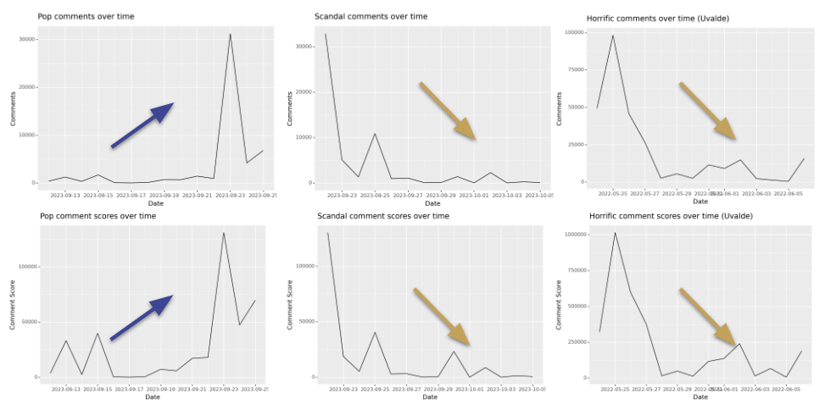

The number of videos posted per day also remained relatively constant until the uptick in reactions on September 23, with around 20 to 40 being posted per day until September 23, which hit over 60 videos posted per day. The number of videos posted were lower than both horrific and scandalous news at their peaks.

The majority of all comments were positive (over 10 percent of comments were classified as such). The number of positive comments remained higher than the number of negative comments throughout the entire 14 days of analysis, and jumped to 2,000 on September 23 (compared to just under 750 negative comments that same day). Very few neutral comments were posted at all.

Difference of means tests were conducted using positive, negative, and neutral dummy variables as the independent variable(s), and comment score as the dependent variable. It was found that both positive and negative comments (i.e. sentiment probability scores greater than 0.7) had a statistically significant positive relationship with comment scores. Specifically, positive comments had an average comments score 12.37 points higher than non-positive comments (p=0.000), and negative comments had average comments scores 7.42 points higher than non-negative comments (p=0.047). Neutral comments did not have a statistically significant relationship with comment scores.

**Figure 2. Sentiment over time on pop news**

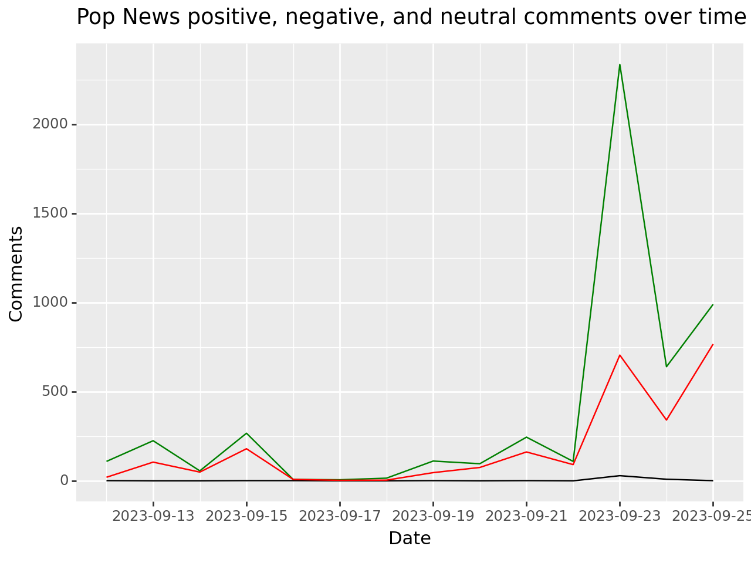

Overall, it is clear that individuals react to pop news in a more positive manner as compared to horrific and scandalous news (which will be discussed shortly). In addition, positive comments received significantly higher comment scores and likes (as did negative comments). It is equally important to note the increase in activity, commenting, and positive sentiment over time– qualities that did not carry over to either scandalous or horrific news.

### Robert Menendez Indictment - Scandalous News

On September 22, 2023, Bob Menendez (a Democratic U.S. Senator from New Jersey) was indicted in “connection with improper foreign relations and business dealings” (Katersky, 2023). He and his wife were accused of receiving money from foreign nations to take actions on their interest (Ibid). The majority of “buzz” surrounding this scandalous news occurred during the first few days of Menendez’s indictment, with over 3,000 comments posted. This number slowly declined over time, with a minor uptick on October 2, when Menendez’s trial date was announced. Interestingly, more videos were (usually) posted per day than for pop news, with over 150 videos being posted the first day alone (compared to less than 40 for horrific news and less than 20 for scandalous news). Sentiment regarding this news was mostly negative. The number of negative comments remained higher than positive comments throughout the 14 days analyzed.

Difference of means test showed similar results to pop news: there was a statistically significant relationship between positive comments and comment score, with positive comments on average having an additional 5.61 point than non-positive comments (p=0.000). Negative comments, too, were likely to generate higher comments scores, with negative comments having 4.36 more points on average (p=0.000). However, neutral comments did not have a statistically significant relationship with comment scores.

An important takeaway from this analysis is that though more videos were usually produced for scandalous news on a per day basis when compared to both pop news and horrific news, the amount of comments made per day were fewer in relation to pop news. Individuals did not react as frequently or as strongly when compared to pop news– comments per video on a per day basis were substantially lower than for pop news, despite having more content overall.

**Figure 3. Sentiment over time on scandal news**

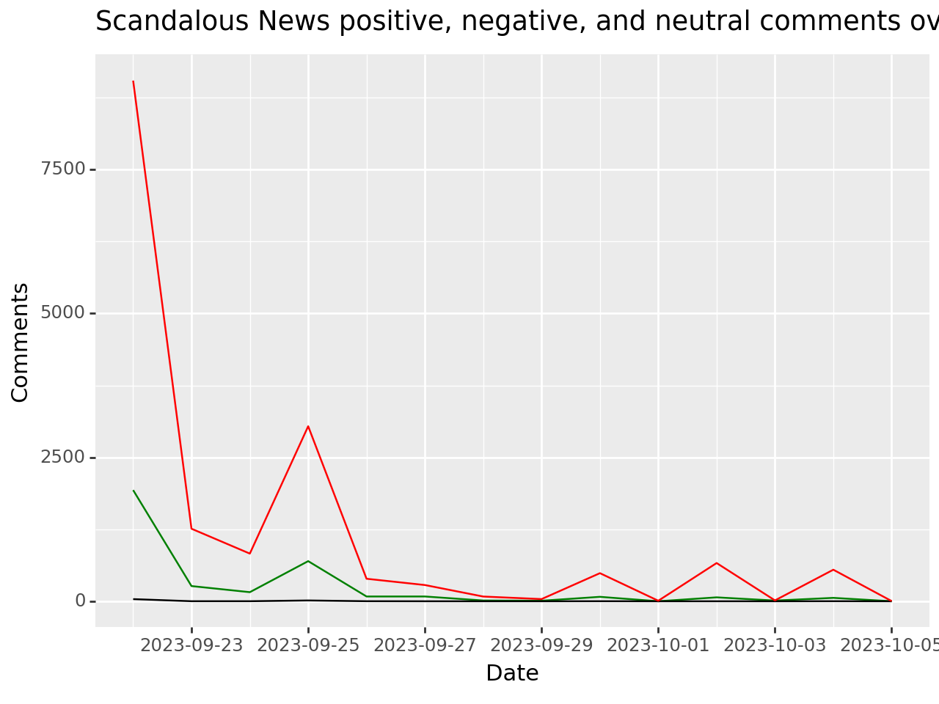

### Uvalde Shooting - Horrific News

On May 24, 2022, in Uvalde Texas a school shooting occurred at Robb Elementary School (Jacobo and El-Bawab, 2022). During the first few days following the tragic shooting, more comments were made on videos about Uvalde compared to pop videos and scandalous videos regarding comments combined: around 5,000 on day one, and almost 10,000 on day two (a number more than twice as large as pop and scandalous news on their best days combined). Though comments declined over time, the number often remained higher than pop and scandalous news. Comment scores overtime followed a similar pattern.

The amount of videos posted during the first few days was around 40 to 80 per day (somewhere in between pop and scandalous news). However, the comment per video ratio was high, often spiking to over 1,500, the highest of all news categories.

Unsurprisingly, sentiment regarding horrific news was overwhelmingly negative. More than 12,000 negative comments were posted on the first day, spiking to over 25,000 on day two. While both positive and negative comments fell over the next few days, Interestingly, positive sentiment increased slightly, to the point where positive comment numbers overtook negative comments on day 8. On this day, news about the shooter’s grandmother (who was horribly injured in the attacks) came out that she would survive (NBC 2022).

**Figure 3. Sentiment over time on horrific news**

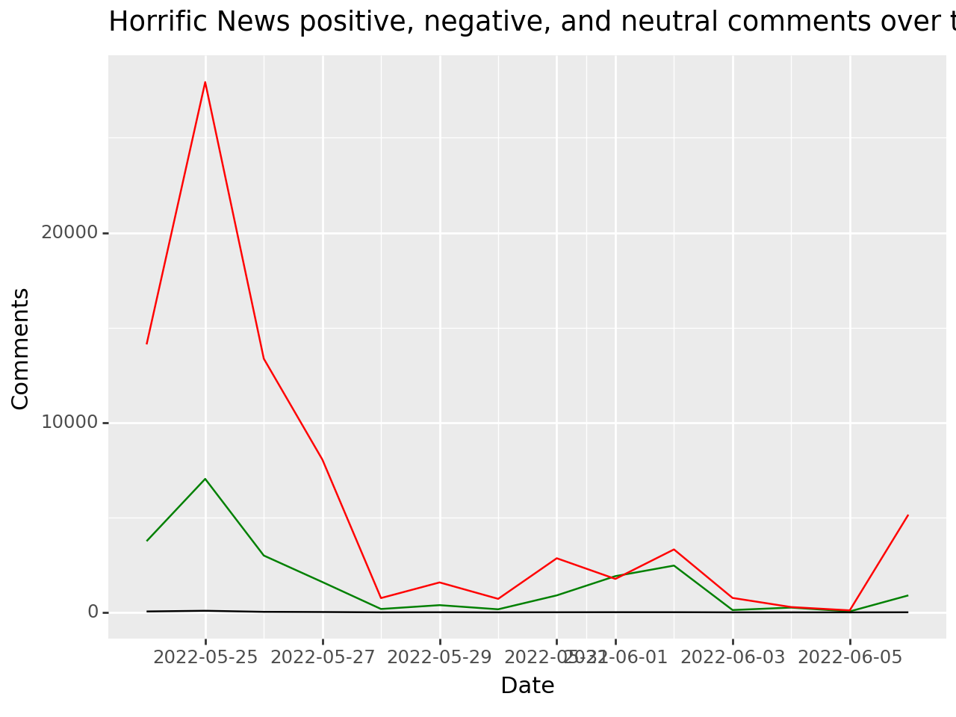

Horrific news followed a similar pattern to both scandalous and pop news regarding the difference of means between sentiment and comment score. Positive comments were on average 12.29 points higher than non-positive comments on comment scores; statistically significant (p=0.000). Negative comments were on average 15.18 comment score points higher than non-negative comments; statistically significant (p=0.000). The effect of neutral comments on comment scores was not statistically significant.

## Discussion and conclusion

Overall, it is clear that horrific news garners extreme reactions. It is also clear that the more emotionally charged events may be, the likelihood of interacting with, liking, or posting a negative or positive comment increases. This is the case not only for horrific news, but for all types of shocking news analyzed in this paper, as proven by the aforementioned regressions. In addition, though comments generally decline over time for both scandalous and horrific news, pop news’s increase in comments over time may follow a different pattern due to its higher positive sentiment, and/or the decrease in preoccupation with tragic events. Our first hypothesis therefore looks to be mostly correct: pop comments generally have more positive sentiment comments, and horrific news has more negative sentiment comments, and people react strongly to news and comments that have a significant effect on them. However, there were very few neutral comments in our analysis, and scandalous news had no more neutral comments on average than pop and horrific news did. Comments also did not become more neutral over time, making our second hypothesis incorrect. However, the amount of positive and negative comments did decrease, indicating that there were more “unclassified comments” (i.e. comments that did not meet the 0.7 probability threshold to be classified as positive/negative/neutral) as time went on.

More research needs to be done on the effects that different news has on people. This report focused on comparing different news stories and found that topics other than “pop” are related with more negative sentiments. However, there is much more to explore regarding the robustness of these findings (for instance, more news stories of each topic could be included, and in different periods). The 14 days selection was a broad belief on the span of attention that the public pays to a news story, but that assumption can be contested. Also, only one news story per type was selected. To be certain of the validity of the selection, and other similar news can be used to check if the effect goes beyond these three stories[2].

Finally, other variables should be considered, such as the country of origin of the news, the type of search, the inclusion of replies and the effect of framing on the stories. Indeed, this report observed three stories mostly relevant for the U.S. public, other research should take into account the effects of the context. And here the videos were taken as the ones with the most views and more related with the search, but different parameters and search terms can affect the results. Also, comment replies were not taken into account as they were not necessarily related to the video, and in other cases it could be relevant for the findings.

This report contributes to the research on this topic establishing a framework to analyze and compare shocking news reactions. Even if many variables are at play and can be chosen differently, this report attempts to make clear the selections made and provide code that helps replicating and furthering the analysis.

## Works Cited

[Alicia Victoria Lozano](https://www.nbcnews.com/author/alicia-victoria-lozano-ncpn1112366). (2023). Uvalde shooter's grandmother in 'good' condition, faces long road to recovery. NBC News. <https://www.nbcnews.com/news/us-news/uvalde-shooters-grandmother-good-condition-faces-long-road-recovery-rcna31525>

Chen, Annie et. al. (2023). Subscriptions and external links help drive resentful users to alternative and extremist YouTube channels. Science Advances

De Hoog, Natasha, and Verboon, Peter (2019). Is the news making us unhappy? The influence of daily news exposure on emotional states. British Journal of Psychology

Deori, Maya, et. al. (2021). Sentiment Analysis of User Comments on Indian Hindi News Channels Using Mozdeh: An Evaluation Based on YouTube Videos. Journal of Creative Communications

Divesh, None, et. al. (2022). Sentiment Analysis on Cryptocurrency using Youtube Comments. International Conference Computing Methodologies and Communication

Glamour. (2023). Taylor Swift and Travis Kelce: A Timeline. Glamour. https://www.glamour.com/story/taylor-swift-and-travis-kelce-timeline

Hussein, Doaa Mohey El Din Mohamed (2016). A survey on sentiment analysis challenges. Journal of

King Saud University: Engineering Sciences

Jacobo, Julia and El-Bawab, Nadine (2022). Timeline: How the shooting at a Texas elementary school unfolded. ABC News. https://abcnews.go.com/US/timeline-shooting-texas-elementary-school-unfolded/story?id=84966910

Katersky, Aaron (2023). Sen. Bob Menendez indicted again for corruption, allegedly had cash stuffed in coat, gold bars. ABC News. https://abcnews.go.com/Politics/sen-bob-menendez-indicted-gifts-gold-bars-car/story?id=103407936

Khomsah, Siti (2021). Sentiment Analysis On YouTube Comments Using Word2Vec and Random Forest. Telematika

Koutra, Danai et. al. (2015). Events and Controversies: Influences of a Shocking News Event on Information Seeking. The Web Conference

Liew, Kongmeng, et. al. (2020). Classification of Nostalgic Music Through LDA Topic Modeling and Sentiment Analysis of YouTube Comments in Japanese Songs. NLP4MUSA

Mike Rosenstein. (2023). Taylor Swift, Travis Kelce ‘very affectionate’ in late-night Chiefs celebration. New York Post. <https://nypost.com/2023/09/25/taylor-swift-clears-out-restaurant-for-dinner-with-travis-kelce/>

Mukwazvure, Addlight and Supreethi, K.P. (2015). A hybrid approach to sentiment analysis of news

comments. 2015 4th International Conference on Reliability, Infocom Technologies and Optimization (ICRITO) (Trends and Future Directions)

MTV VMA. (2023). “Winners.” MTV. <https://www.mtv.com/vma/vote/>

Nicki Brown and [Holmes Lybrand](https://www.cnn.com/profiles/holmes-lybrand). (2023). Judge sets May 6 trial date in bribery case against Sen. Menendez. CNN. <https://www.cnn.com/2023/10/02/politics/senator-menendez-trial-date-may-6/index.html>

Postalcioglu, Seda, et. al. (2020). Comparison of Neural Network Models for Nostalgic Sentiment Analysis of YouTube Comments. Hittite Journal of Science & EngineeringPoutvaara, Panu and Ropponen, Olli (2018). Shocking news and cognitive performance. European Journal of Political Economy

Shanmugavadivel, Kogilvani, et. al. (2022). Overview of the Shared Task on Sentiment Analysis and Homophobia Detection of YouTube Comments in Code-Mixed Dravidian Languages. Fire

Sharma, Shivam and Soni, Hemant Kumar (2021). Viewer Sentiments on Game of Thrones: An Automated Lexicon-Based Sentiment Analysis on Real-Time YouTube Comments. Algorithms for Intelligent Systems

Shevtsov, Alexander, et al. (2020). Analysis of Twitter and YouTube during USelections 2020.. arXiv: Social and Information Networks

Singh, Ritika and Tiwari, Ayushka (2021). YOUTUBE COMMENTS SENTIMENT ANALYSIS. International Journal of Scientific Research in Engineering and Management (IJSREM)

Thelwall, Mike, et. al. (2012). Commenting on YouTube videos: From Guatemalan rock to El Big Bang. [Journal of the American Society for Information Science and Technology](https://onlinelibrary.wiley.com/journal/15322890)

Zhou, Shuhua et. al. (2008). Effects of Morbid Curiosity on Perception, Attention, and Reaction to Bad News. The University of Alabama McNair Journal

Similarweb. (2023). Top Website Rankings. <https://www.similarweb.com/top-websites/>

Pew Research Center. (2023). News Platform Fact Sheet. Pew Research Center.

<https://www.pewresearch.org/journalism/fact-sheet/news-platform-fact-sheet/>

User: [Lxyuan](https://huggingface.co/lxyuan). (2023). [“Distilbert-base-multilingual-cased-sentiments-student”](https://huggingface.co/lxyuan/distilbert-base-multilingual-cased-sentiments-student).

[https://huggingface.co/lxyuan/distil.bert-base-multilingual-cased-sentiments-student](https://huggingface.co/lxyuan/distilbert-base-multilingual-cased-sentiments-student)

1. We used the library python-youtube (https://pypi.org/project/python-youtube), built to make an easier usage of Youtube’s API from Python
2. We have reason to believe it does as we also gathered data on the start of the war in Ukraine (query: Ukraine, Russia, invasion; date: '2022-02-24'; n-days: 14) and found that the negative sentiments hold in that scenario as well. These results are on the Github of the report.